Campus Facility Booking and Billing System



Submitted by:
Mirza Zain Ali Baig 2025(S)-SE-20
Muhammad Hamza Shahid 2025(S)-SE-08
Muhammad Sohaib Aslam 2025(S)-SE-13

Submitted to:
Dr. Zeeshan Ramzan

Department of Computer Science
University of Engineering and Technology Lahore, New Campus

Contents
1. SDLC – Waterfall Model 3
2. UML Diagrams 7
2.1. Class Diagram 7
2.2. Use Case Diagram 8
2.3. Object Diagram 9
2.4. Package Diagram 10
2.5. Sequence Diagrams 11
2.6. Collaboration Diagrams 33
2.7. Deployment Diagram 56
2.8. Component Diagram 57
2.9. Activity Diagrams 58
2.10. State Chart Diagrams 88

SDLC – Waterfall Model
Introduction
In this project, we use the waterfall model. The Waterfall Model is a software development model in which work is completed step by step in a fixed order. In this model, one phase must be completed before moving to the next phase. The main phases include requirement analysis, design, implementation, testing, deployment, and maintenance.
Reason for Choosing Waterfall Model
The Waterfall Model was selected for this project because it provides a simple, structured, and systematic approach to software development. Since the project requirements were clearly defined at the beginning, the Waterfall Model helped in completing the work phase by phase, including requirement analysis, system design, implementation, testing, and maintenance. This model ensured proper documentation, easy project management, and better understanding among team members throughout the development process. It was especially suitable for this project because each stage could be completed and reviewed before moving to the next stage, reducing confusion and improving overall project organization.
Phases
The following illustration is a representation of the different phases of the Waterfall model:

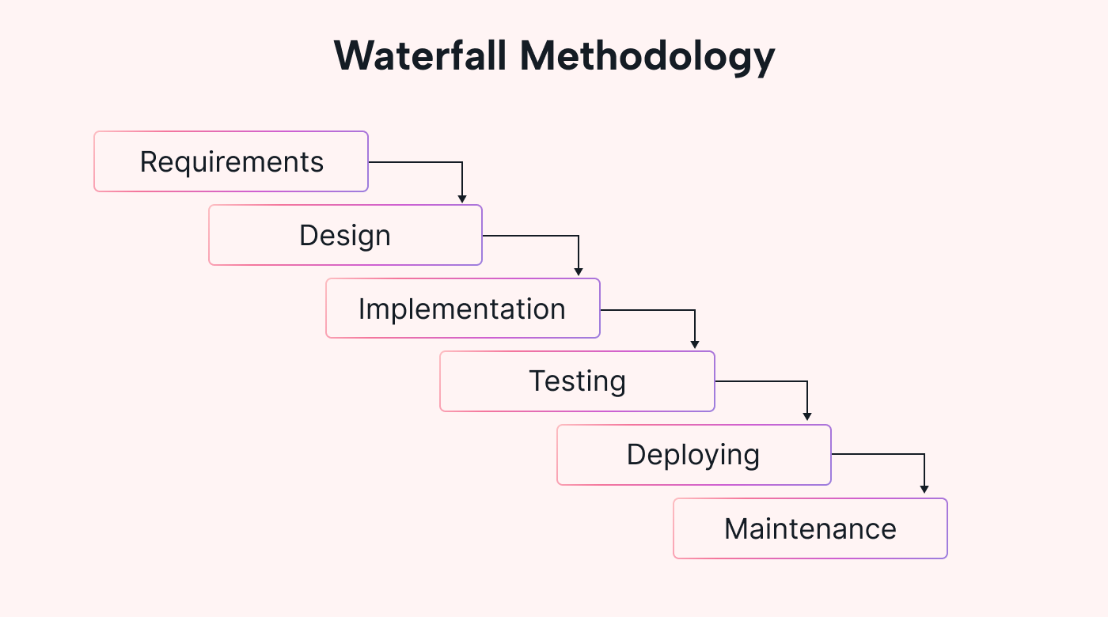
Figure 1: Waterfall Model

The sequential phases in Waterfall model are:
- Requirement Gathering and Analysis
In the Requirement Gathering and Analysis phase, all the needs and expectations of the system are collected from the client or users. The developers try to understand what features the system should have and what problems it should solve. After collecting this information, it is carefully studied and organized to avoid confusion. All the requirements are then written in a document called the Software Requirement Specification (SRS), which is used as a reference for the whole project. This phase is very important because if the requirements are clear, the rest of the project becomes easier to design and develop.

- System Design
In the System Design phase, the requirements collected in the first phase are used to plan how the system will work. Developers create the overall structure of the system and decide how different parts will connect with each other. They also design the database, user interface, and system architecture. This phase helps in understanding how the system will look and function before starting coding. A good design makes the development process easier, faster, and more organized.

- Implementation
In the Implementation phase, the actual coding of the system is done. The system design is converted into a working program using a programming language. The project is divided into small parts called modules or units, and each part is developed separately. After writing the code, each unit is tested to make sure it works correctly. This phase is the main step where the real software is built.

- Integration and Testing
In the Integration and Testing phase, all the small parts (modules) of the system are combined to form the complete system. After joining them, the whole system is tested to check if everything is working correctly. Any errors, bugs, or issues are found and fixed in this phase to make sure the system runs smoothly.

- Deployment
In the Deployment phase, the final tested system is delivered to the client or released for users to use. It is installed in the real environment where it will be used.

- Maintenance
In the Maintenance phase, the system is regularly updated after deployment. Any problems found are fixed, and new features or improvements are added to keep the system working properly.

Advantages
The advantages of the Waterfall Model are that it provides clear structure and control over the development process. A timeline can be planned with fixed deadlines for each phase, and the project moves step by step through all stages like requirement analysis, design, implementation, testing, deployment, and maintenance. Each phase is completed in order before moving to the next one, which makes the process organized and easy to follow.
Some of the main advantages of the Waterfall Model are as follows:
• Simple and easy to understand and use
• Easy to manage because each phase has clear steps and deliverables
• Each phase is completed one at a time
• Best for small projects where requirements are already clear
• Clearly defined stages of development
• Easy to set milestones and track progress
• Tasks can be arranged in a proper order
• Proper documentation is maintained for each phase
Disadvantages
The disadvantage of the Waterfall Model is that it does not allow easy changes once a phase is completed. If a mistake is found in the later stages, it is very difficult and costly to go back and fix it because each phase depends on the previous one. This model is also not flexible, so it does not handle changing requirements well. Another issue is that working software is only available at the end of the project, which increases risk and uncertainty during development.
Some of the main disadvantages of the Waterfall Model are as follows:
• No working software is produced until the final stage
• High risk and uncertainty during development
• Not suitable for complex or object-oriented projects
• Not good for long-term or ongoing projects
• Difficult to handle changing requirements
• Hard to measure progress during development stages
• Changing scope during development can cause project failure
• Integration happens at the end, so problems are found late

2. UML Diagrams

2.1. Class Diagram

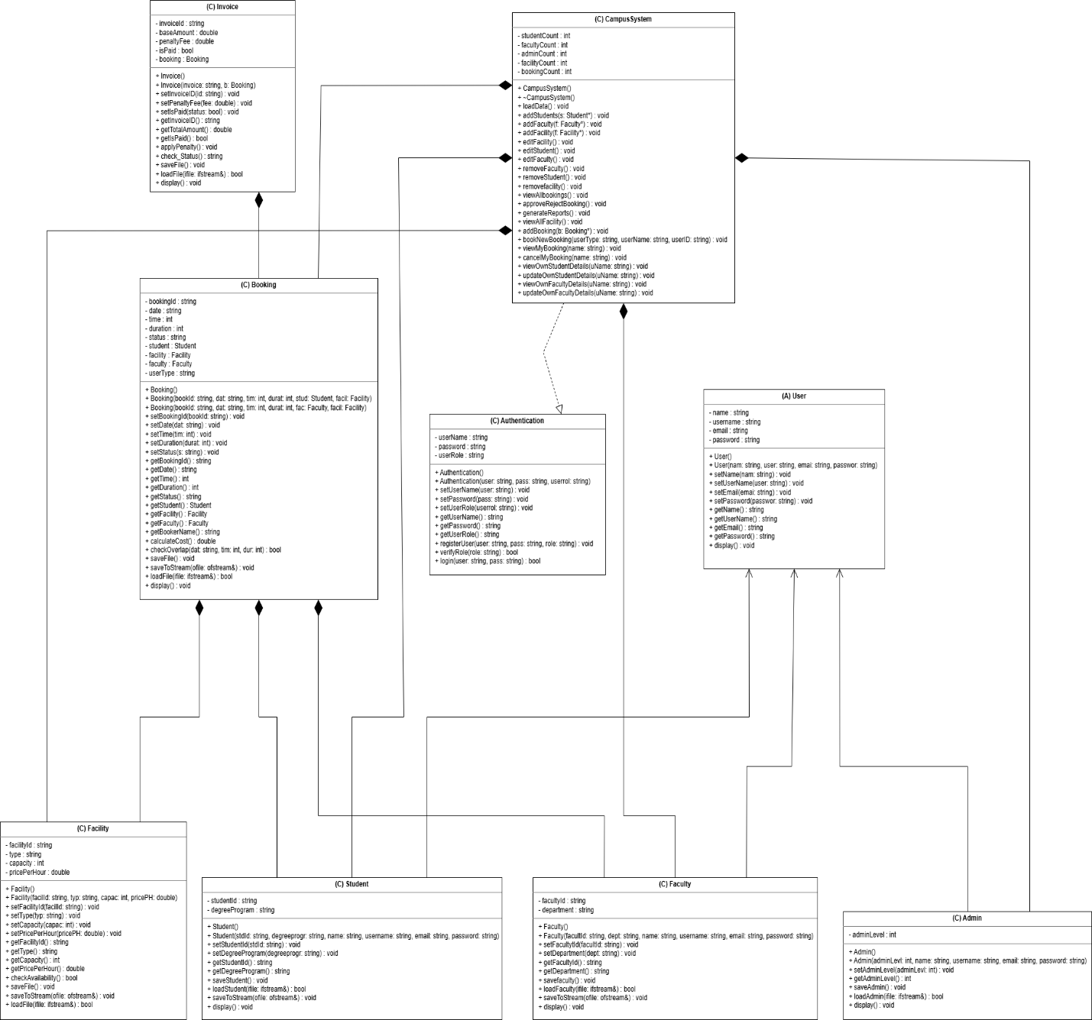

2.2. Use Case Diagram
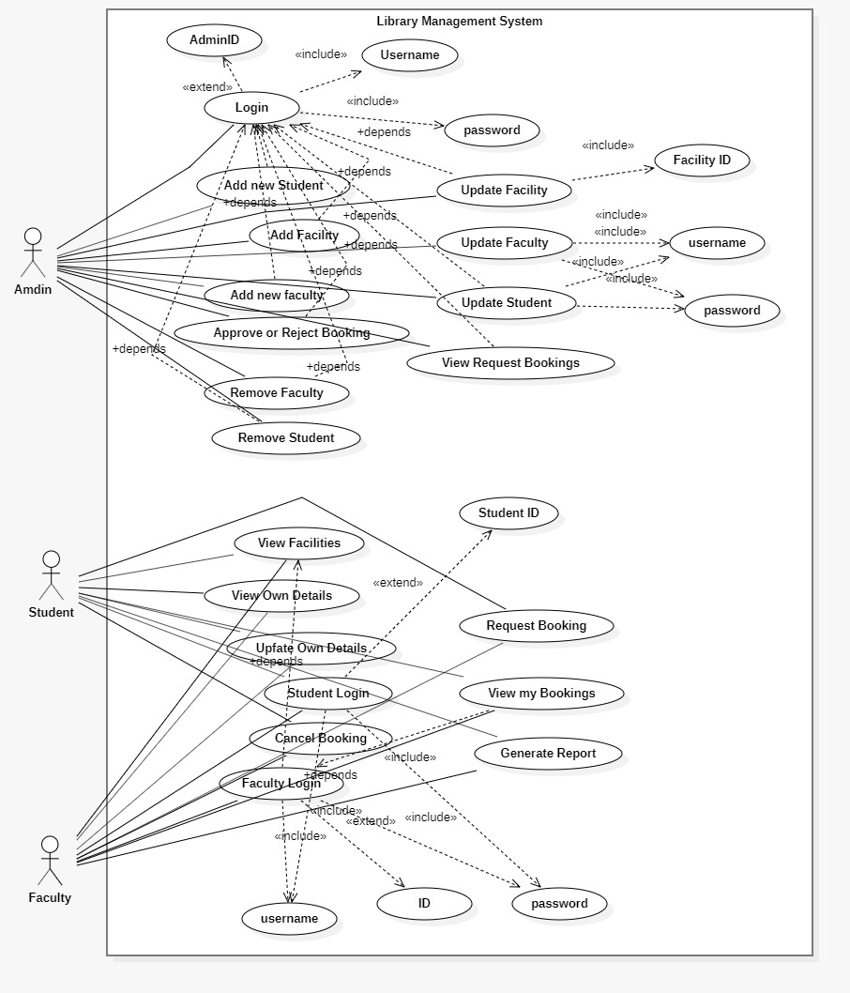

2.3. Object Diagram

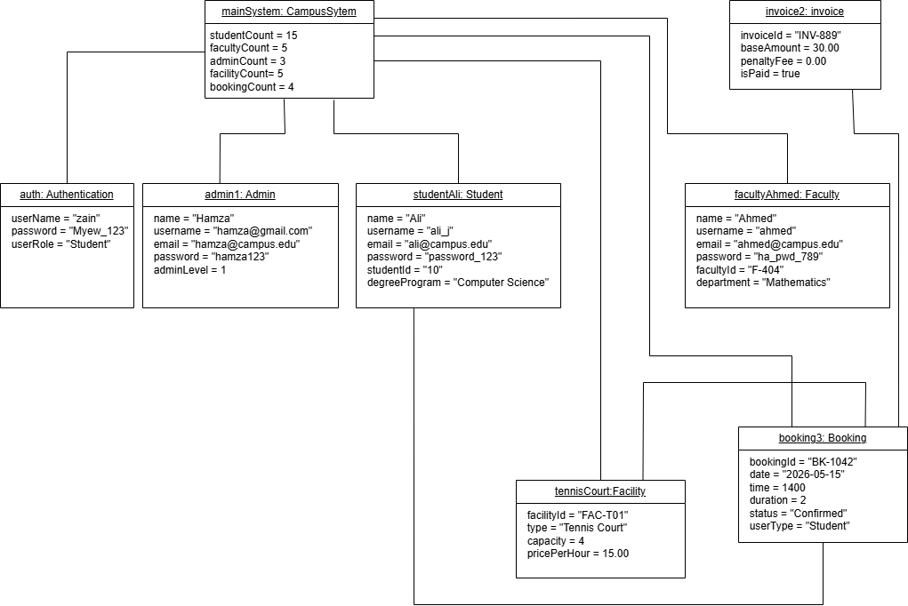

2.4. Package Diagram

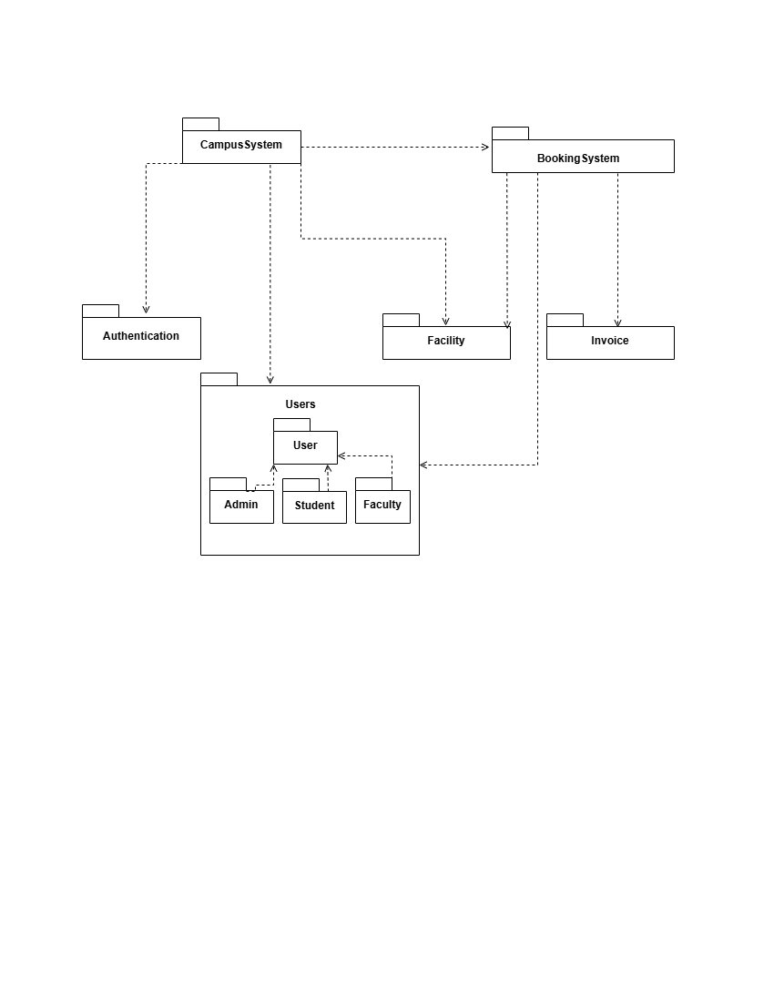

2.5. Sequence Diagrams

Admin

Admin Login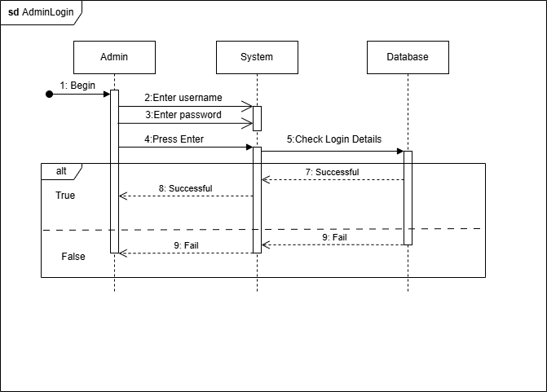

Add New Facility
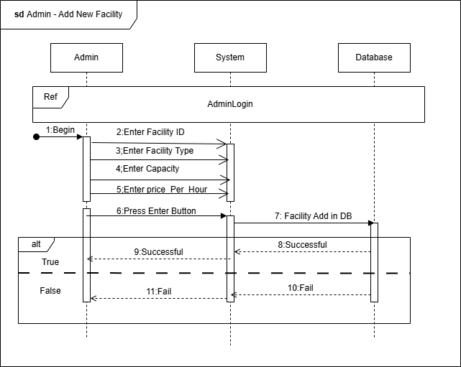

Add Student/Faculty

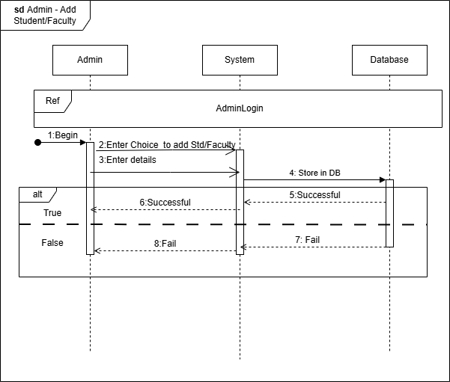

Approve/Reject Booking

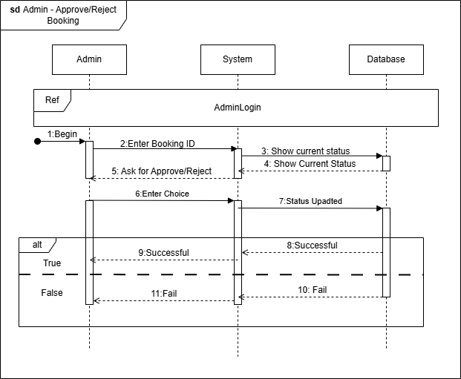
Generate Reports

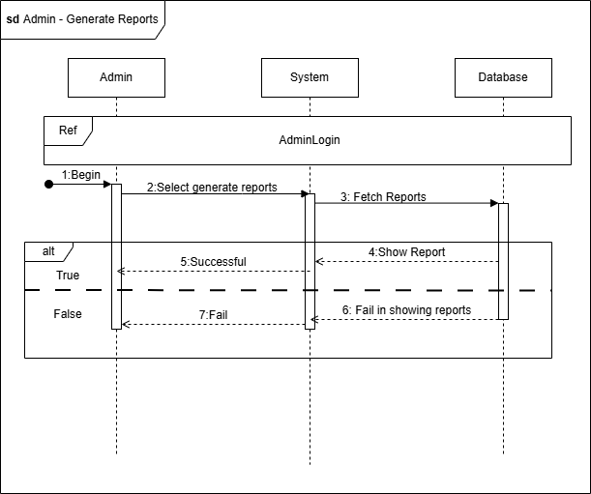
Remove Facility
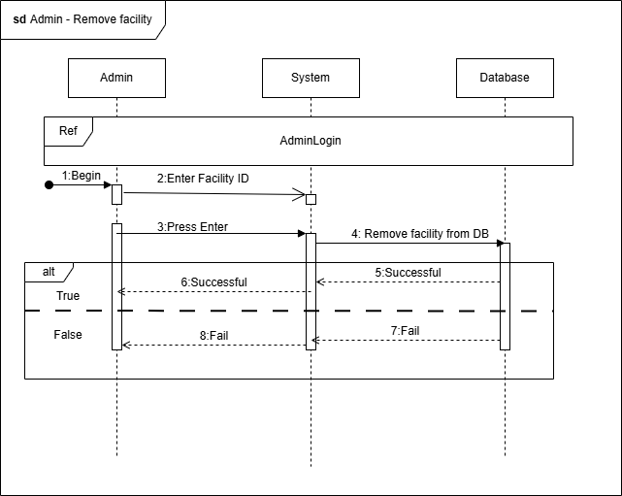
Remove Student/Faculty

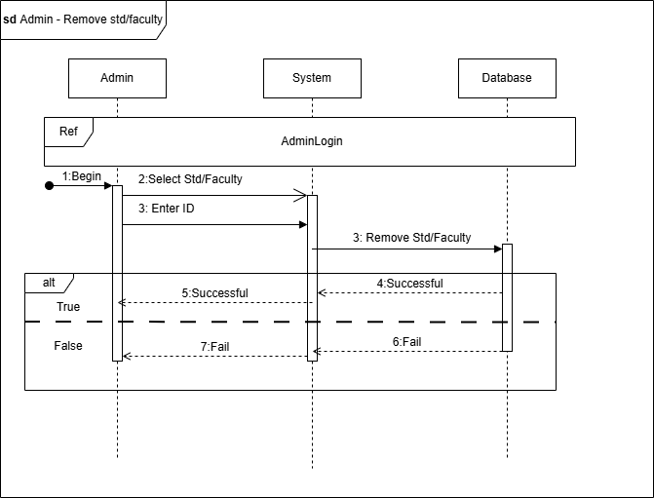

Update Facility

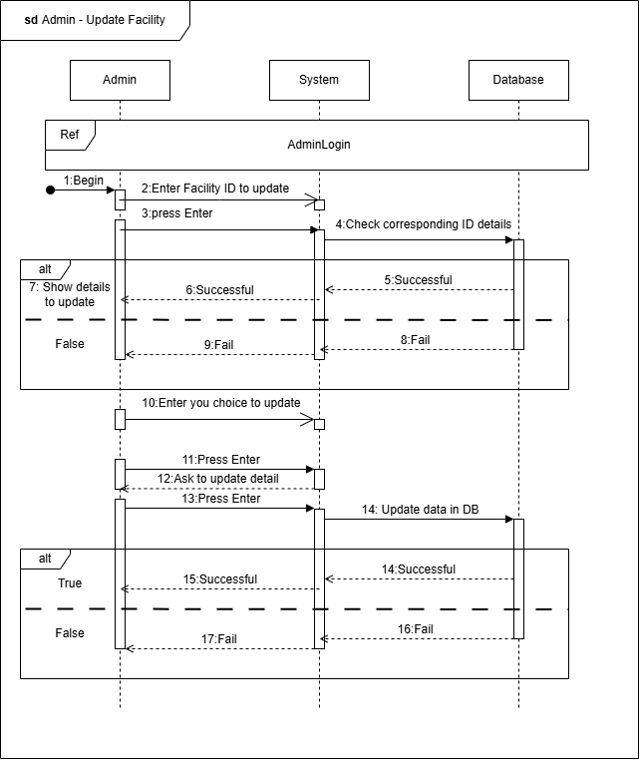

Update Student/Faculty

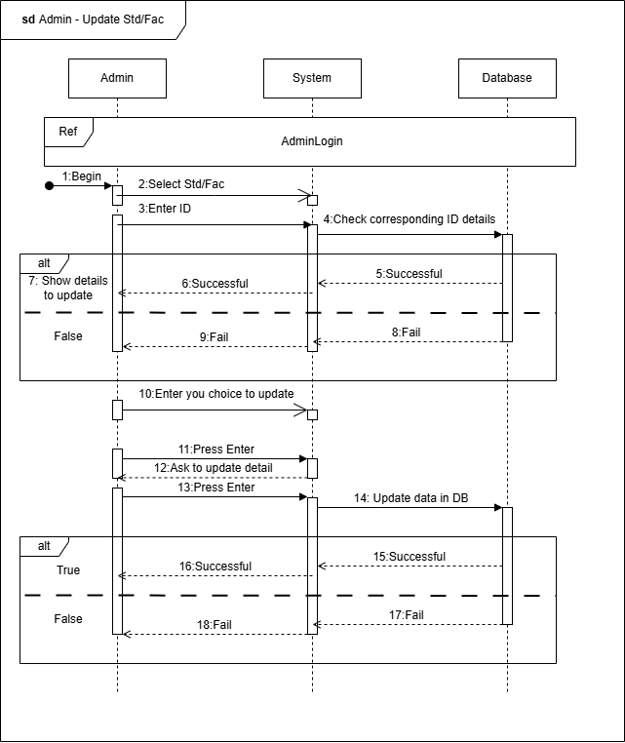
View Booking Requests

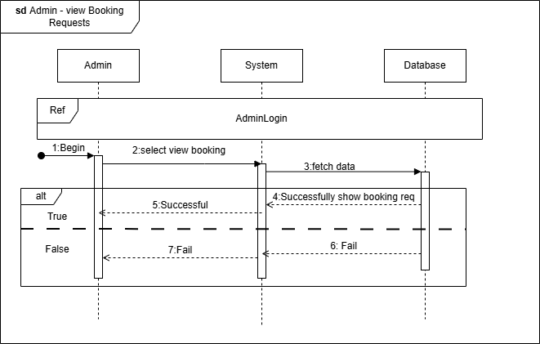
View Facilities

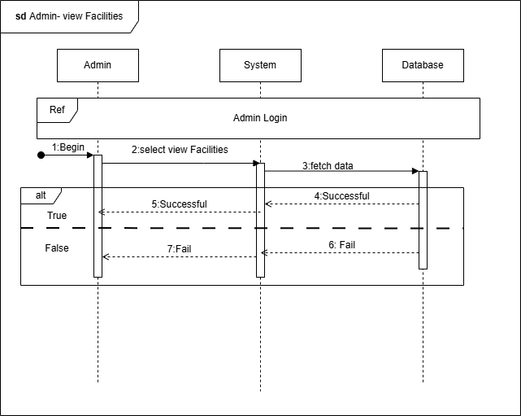

Student
Login

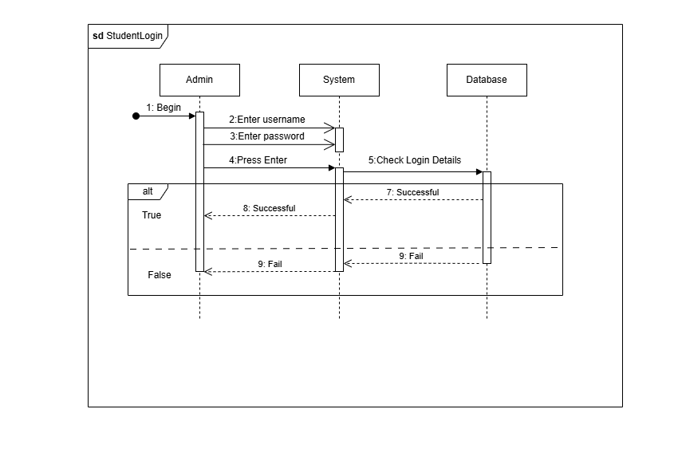

Cancel Booking
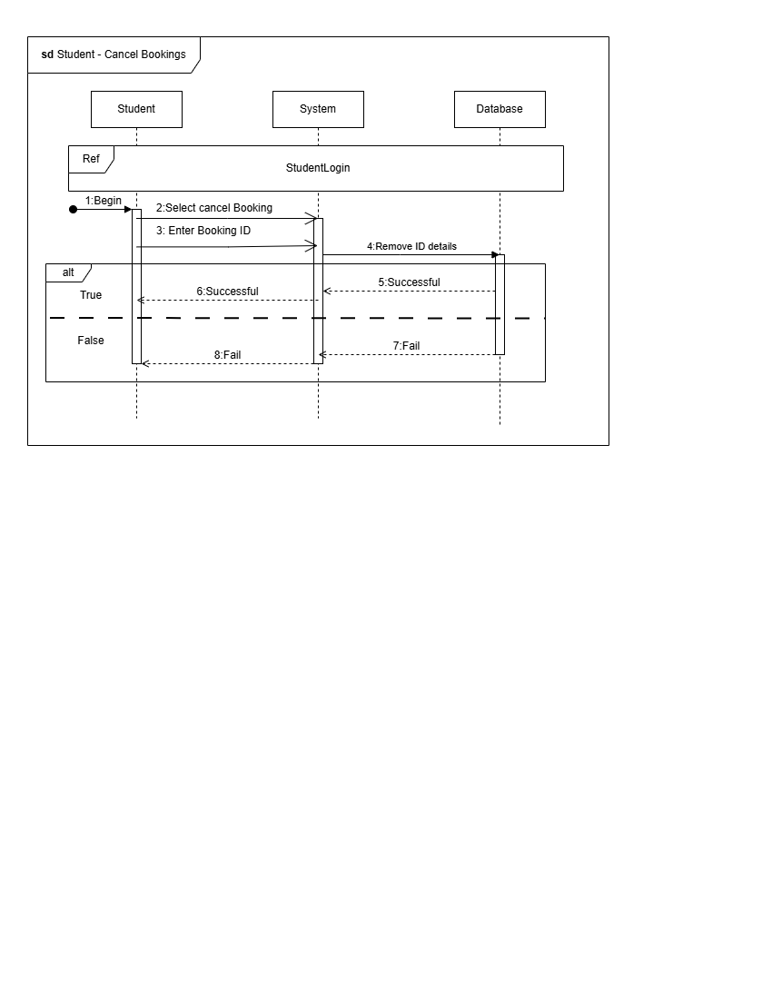

Request Booking
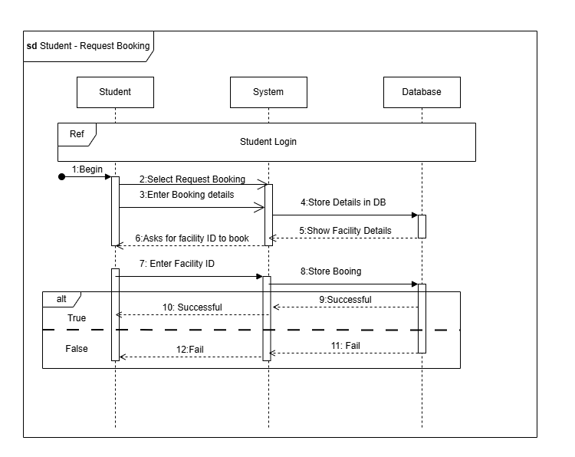

Update Own Details

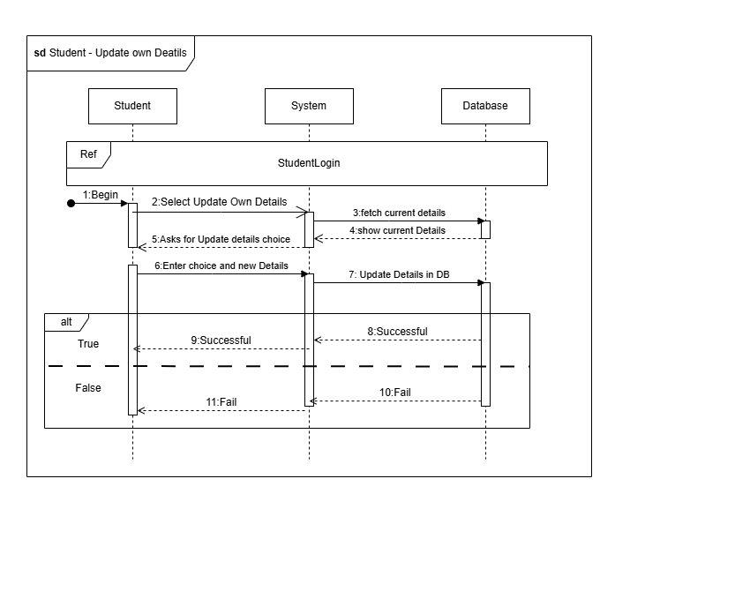

View My Bookings

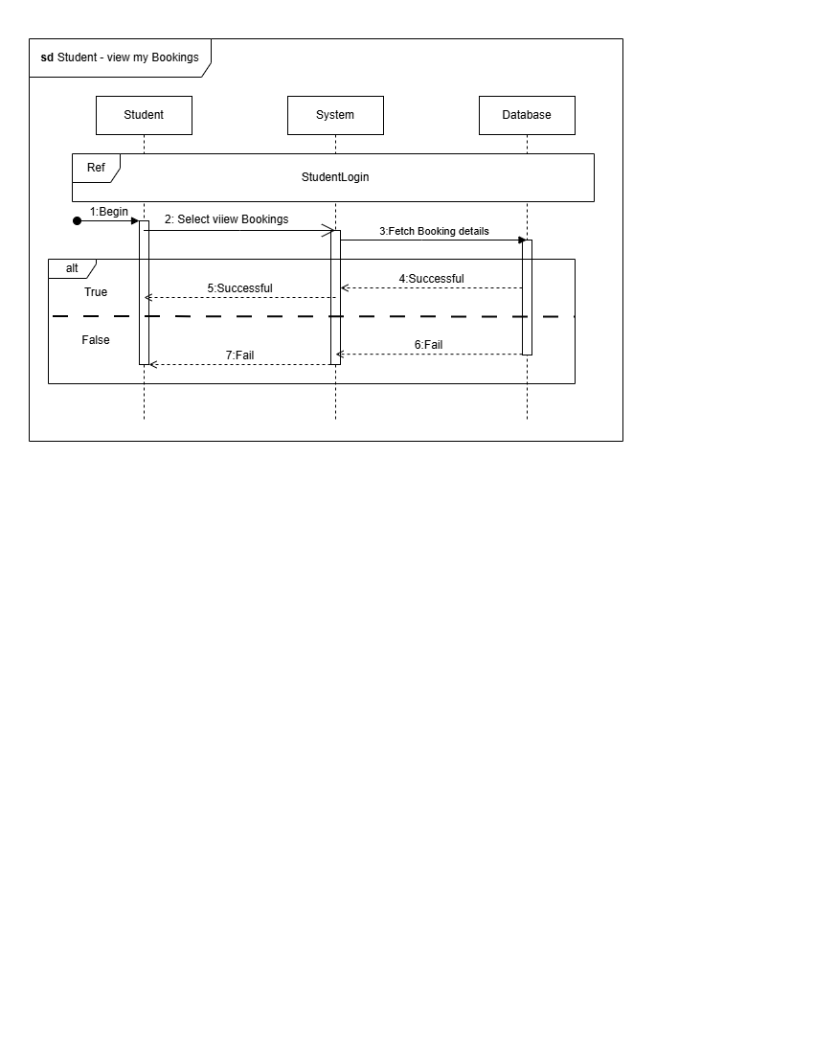
View Own Details
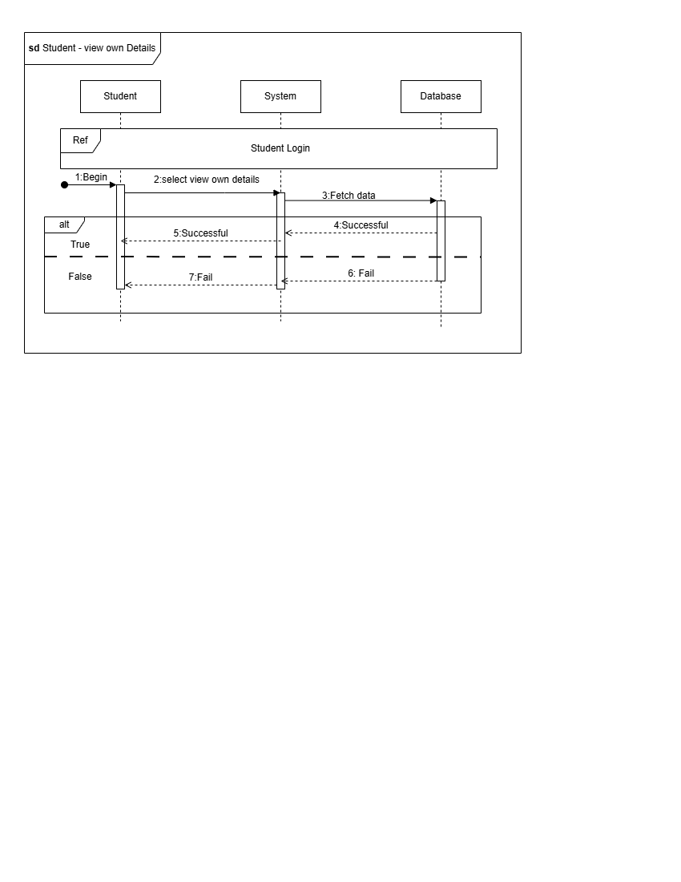
Faculty

Login

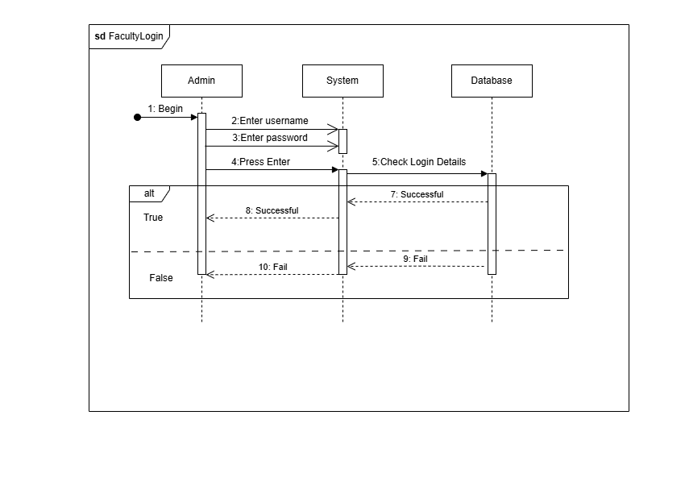
Cancel Booking
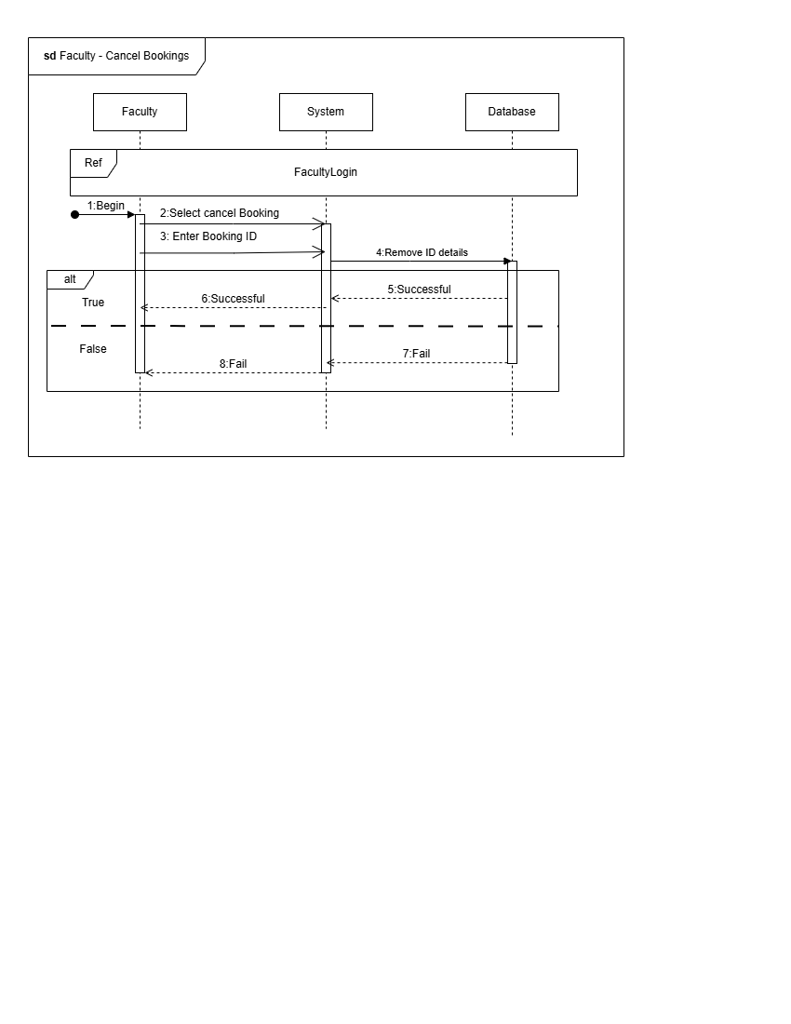

Request Booking

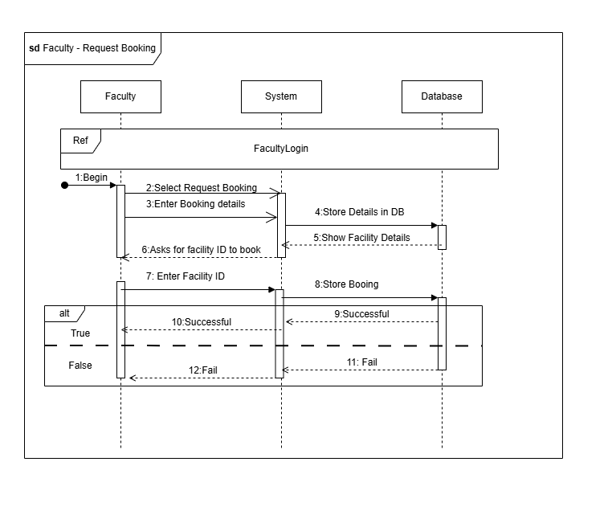

Update Own Details
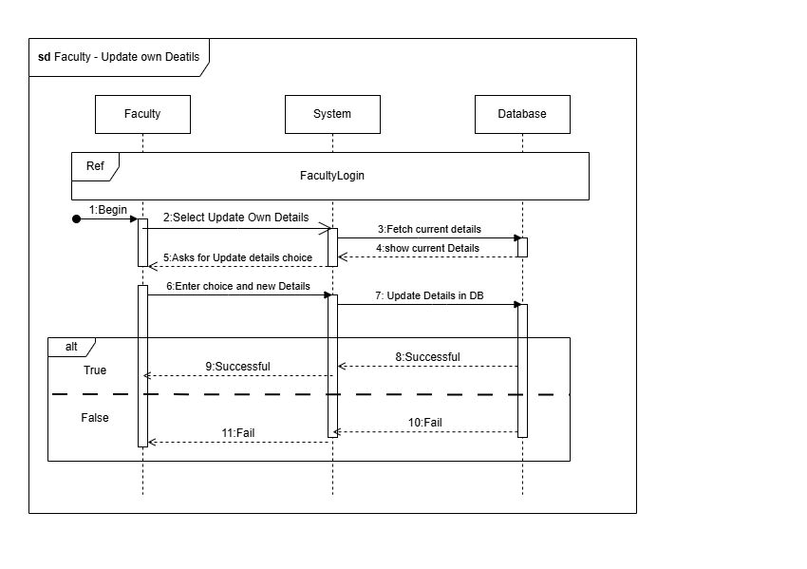

View my Bookings
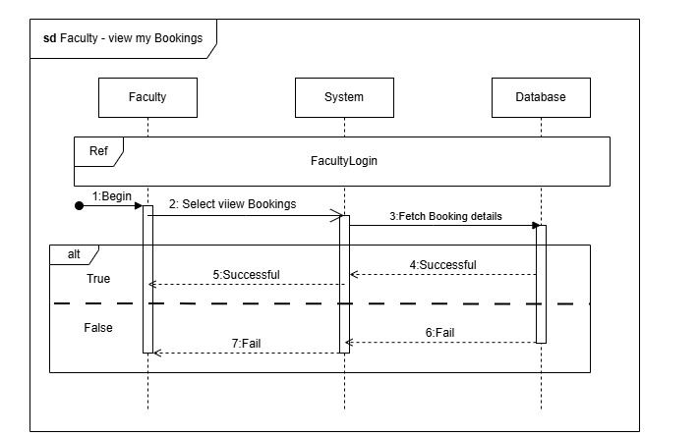
View own details
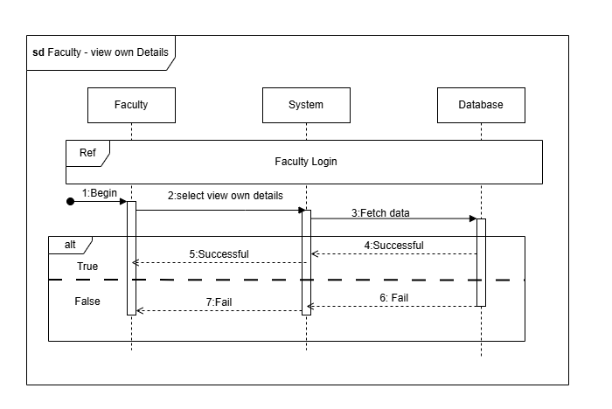

2.6. Collaboration Diagrams

Admin
Admin Login
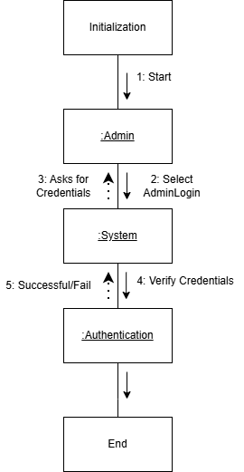

Add New Facility

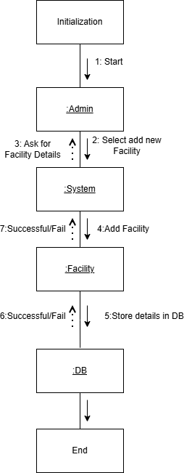

Add Student and Faculty
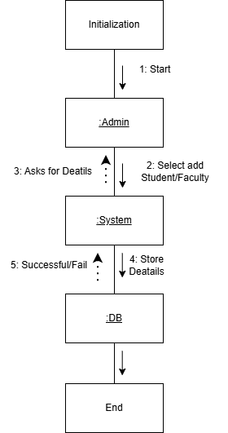

Approve Reject Booking
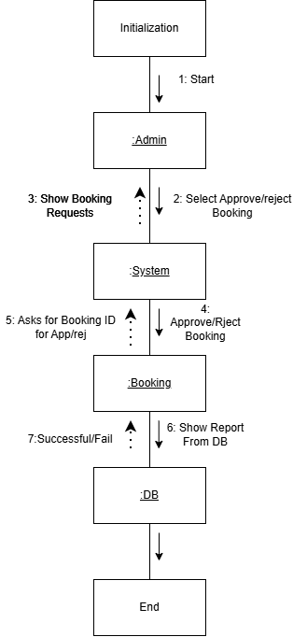

Generate reports

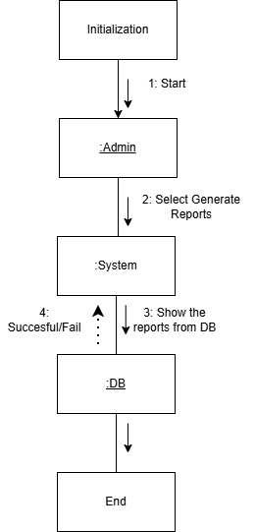

Remove Facility
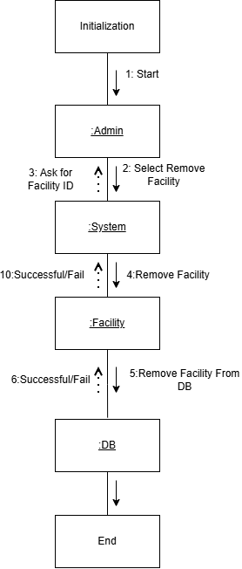

Remove Student/Faculty

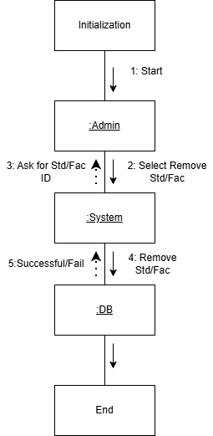

Update Student/Faculty
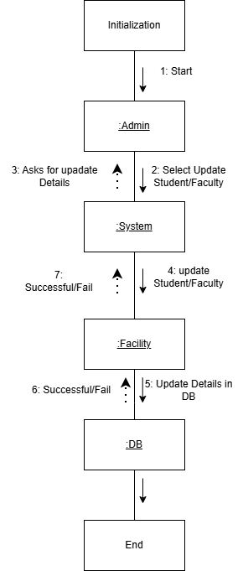

Update Facility
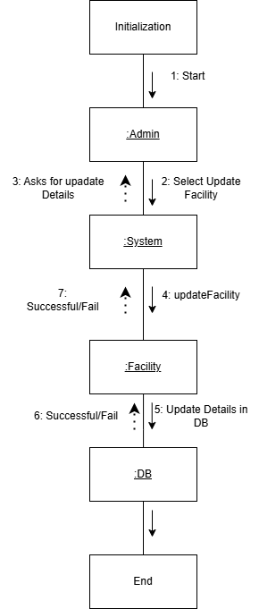

View Booking Requests
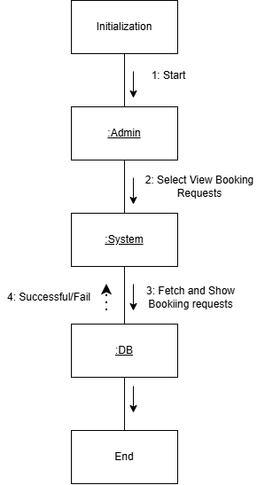

View Facilities

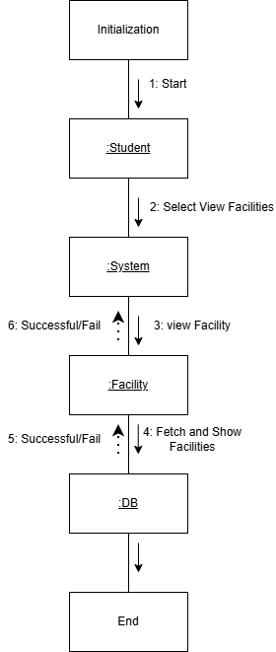

Student
Login
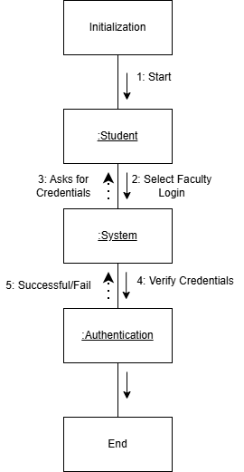

Cancel Booking
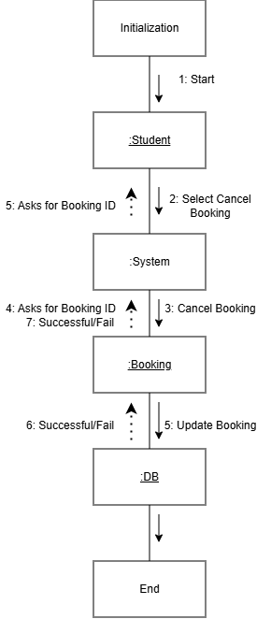
Requests Booking

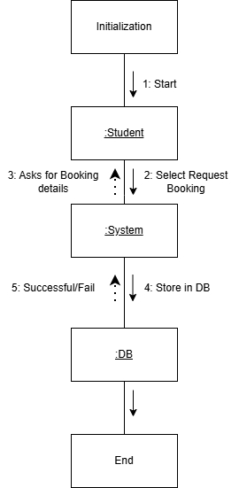

Update own Details

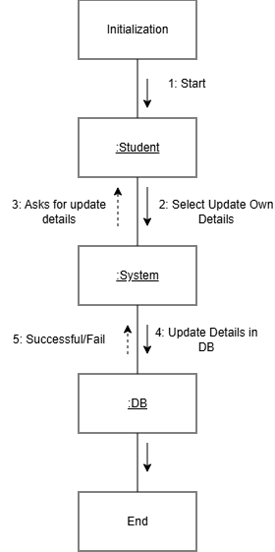

View my Bookings

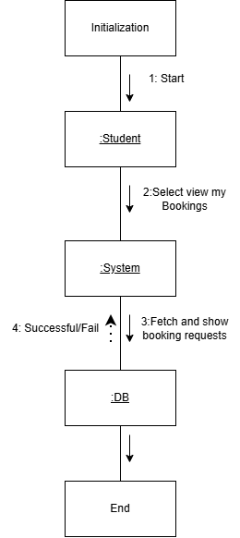
View Own Details

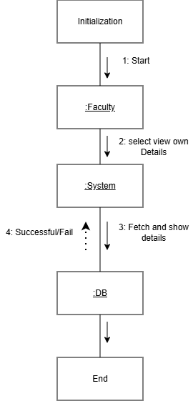

Faculty
Login

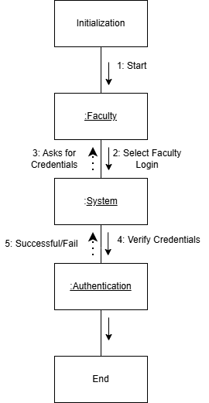

Cancel Booking

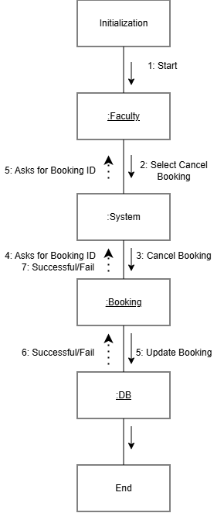
Request Bookings

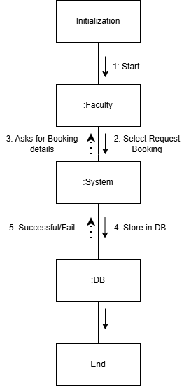
Update own Details

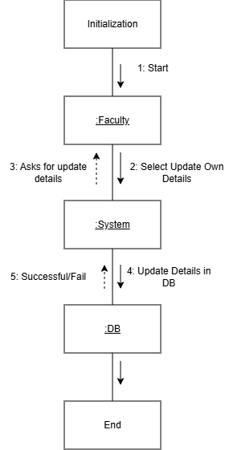
View my Bookings

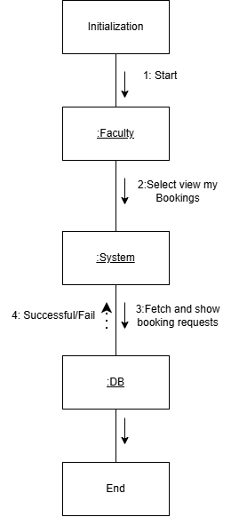
View Own Details

2.7. Deployment Diagram
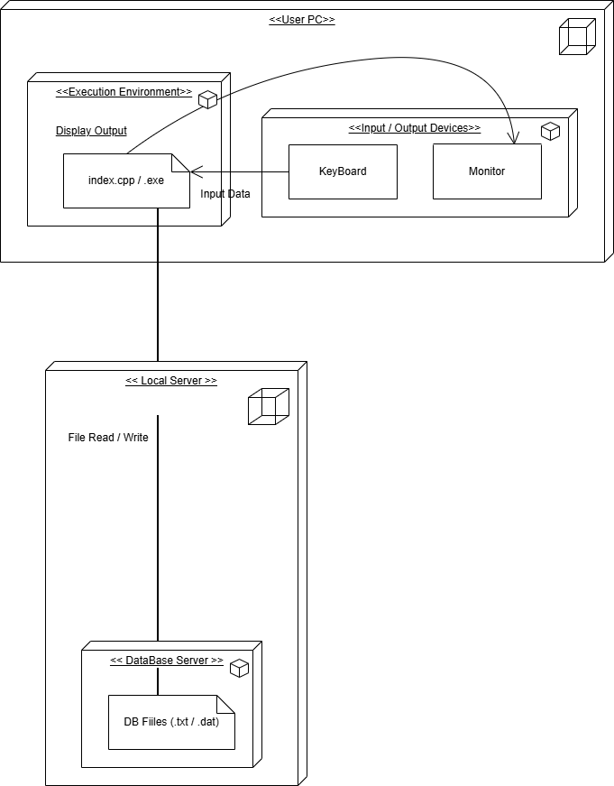

2.8. Component Diagram
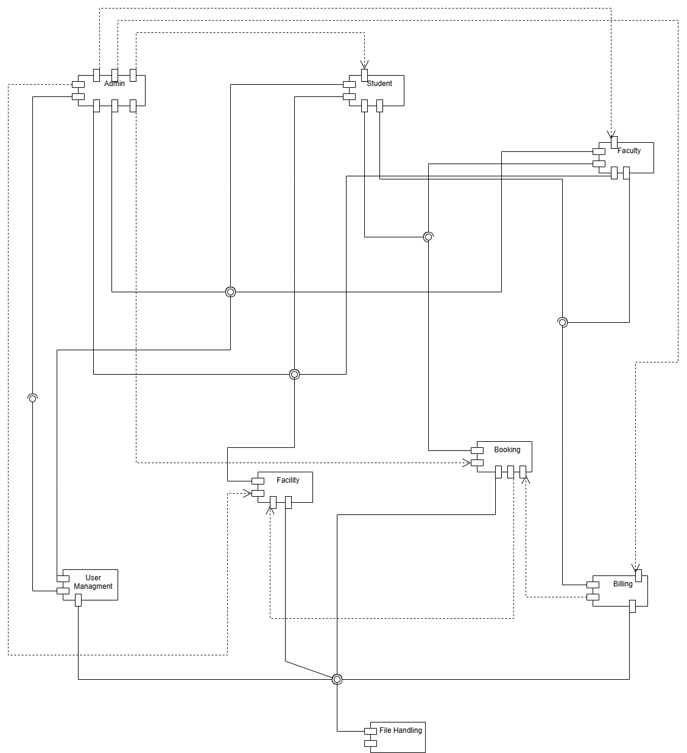

2.9. Activity Diagrams
Admin

Login

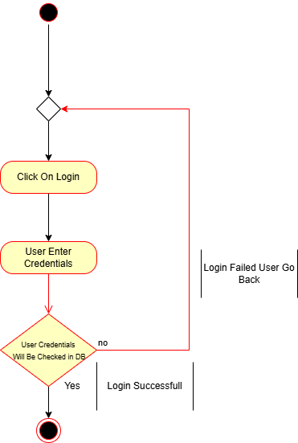

Logout

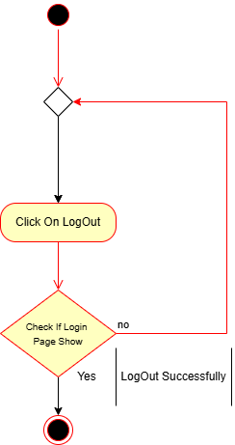

Add New Facility

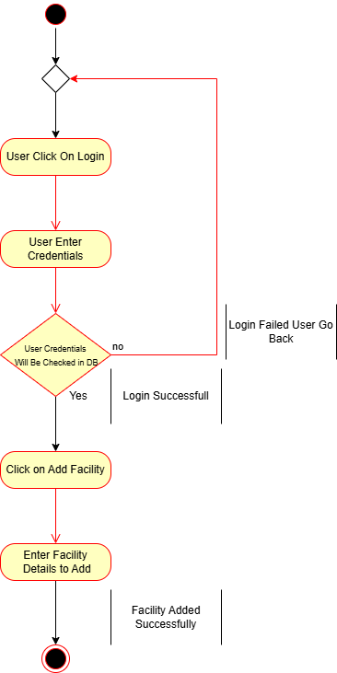

Add New Faculty

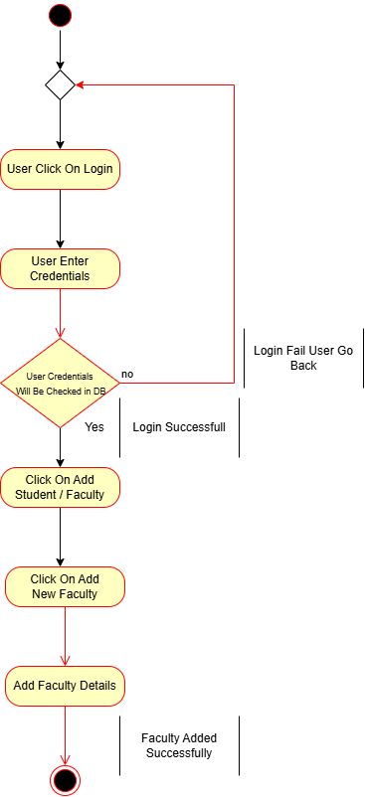

Add New Student
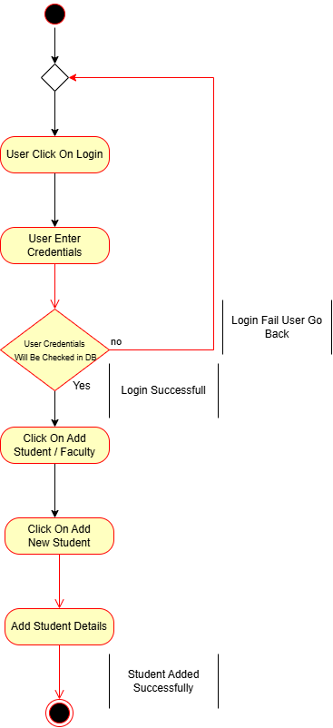

Approve Or Reject Booking

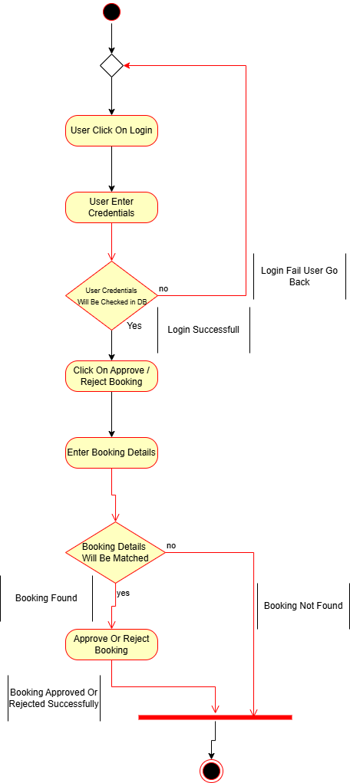

Generate Report
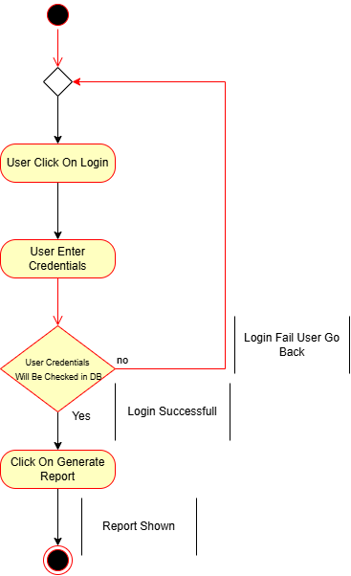

Remove Facility

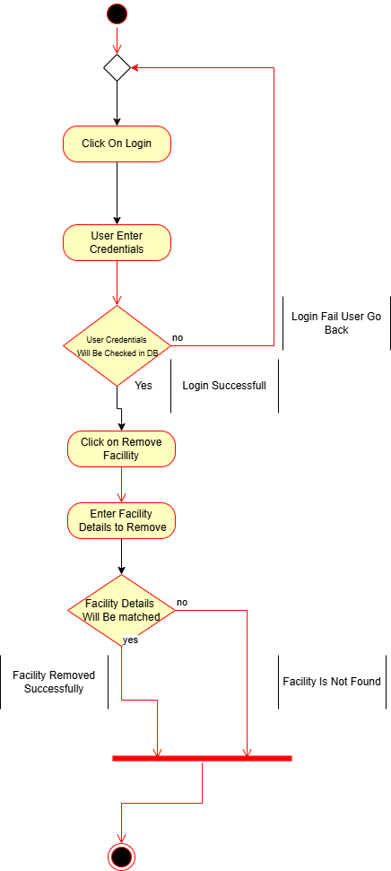

Remove Faculty
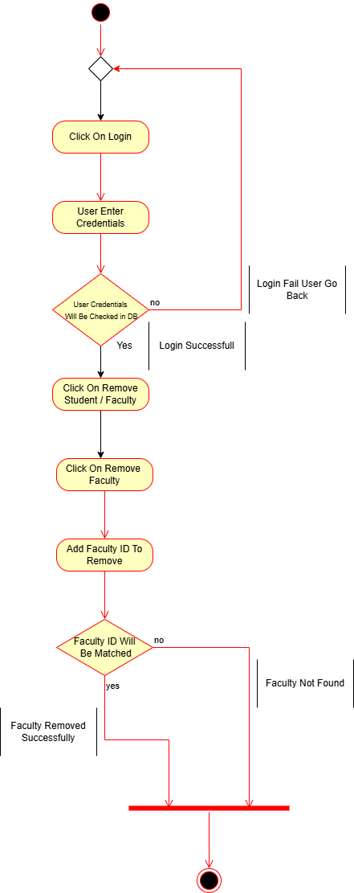

Remove Student

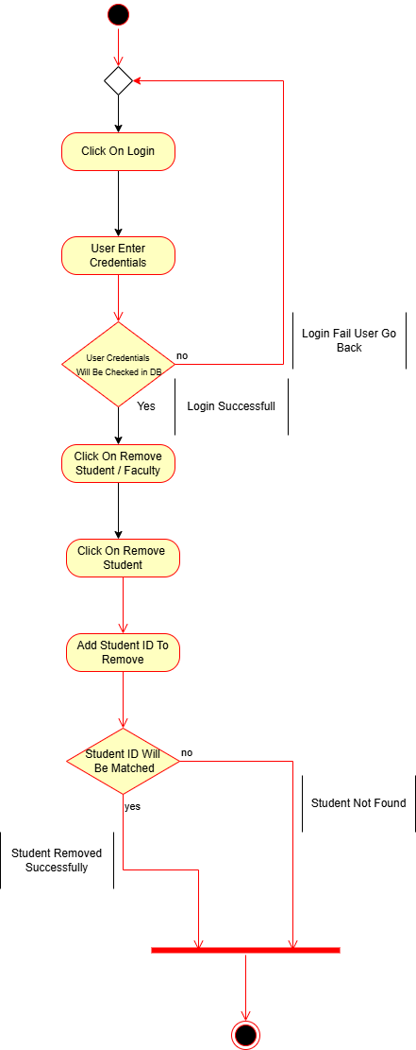

Update Facility
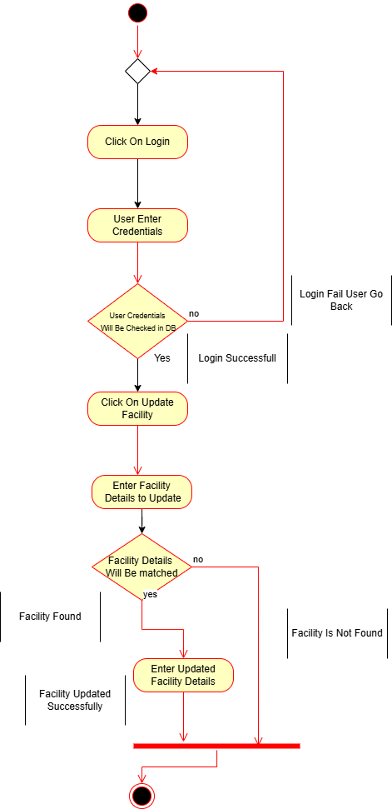

Update Faculty

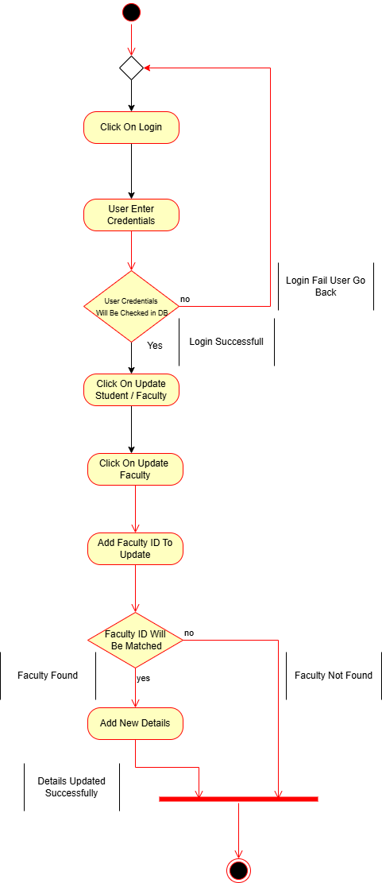

Update Student

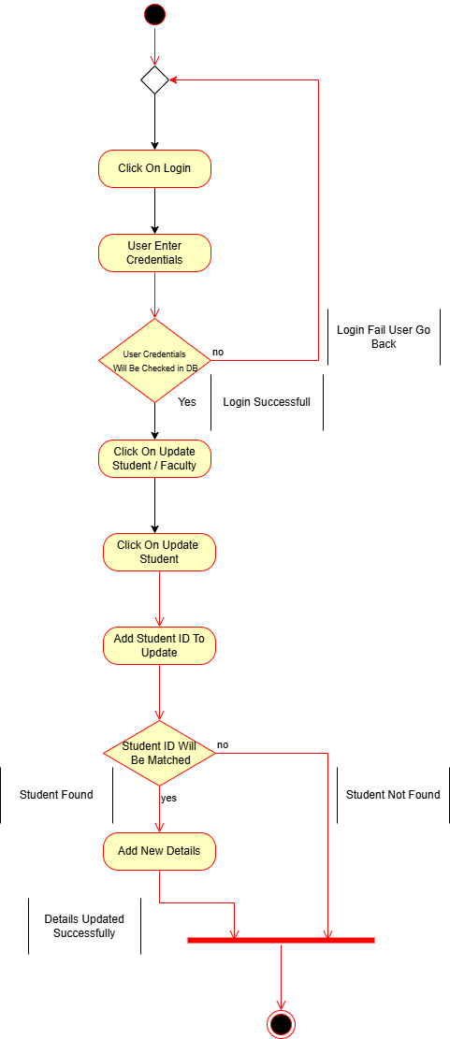

View Booking Requests

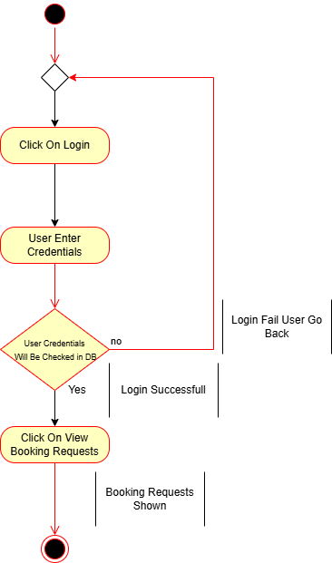

Faculty

Login

Logout

Request Booking

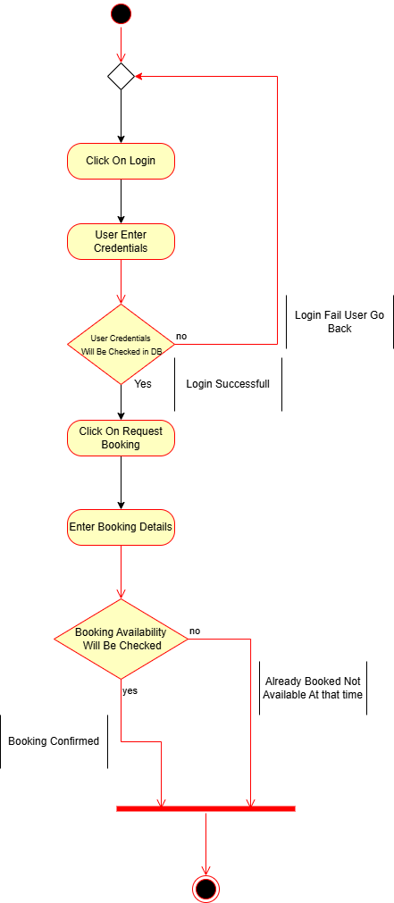

Cancel Booking

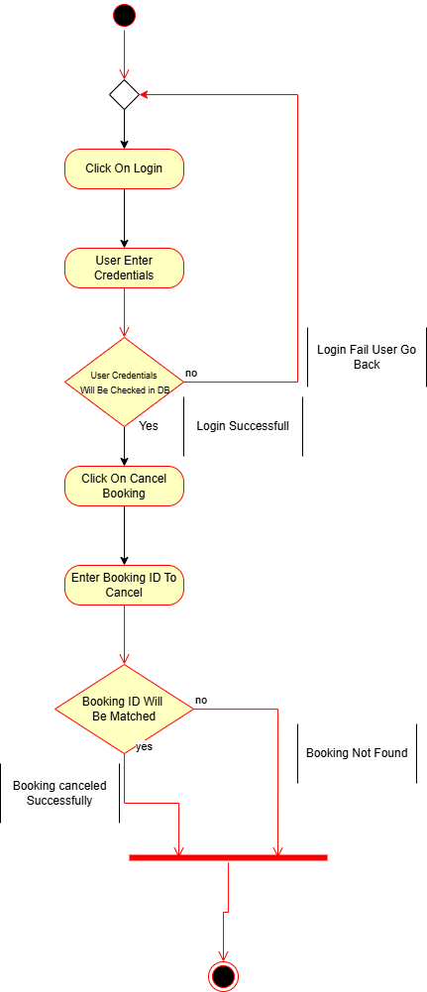

Update Own Details

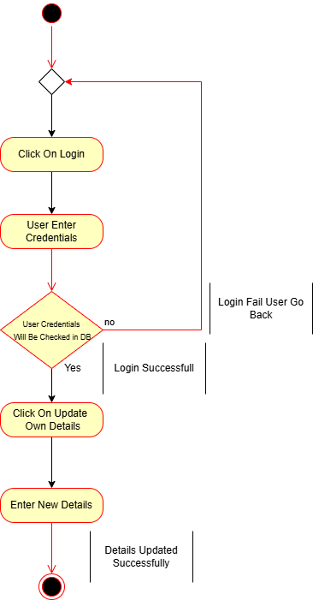

View Facilities

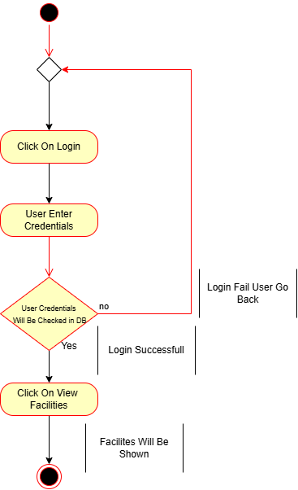

View Own Bookings

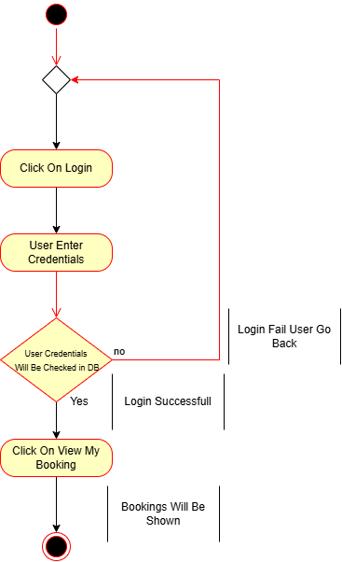

View Own Details

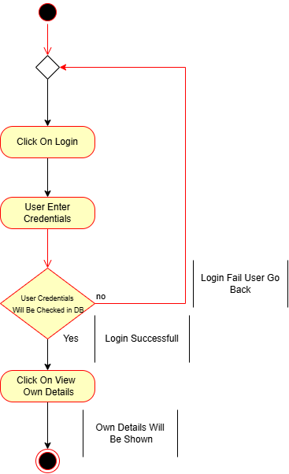

Student

Login

Logout

Request Booking

Cancel Booking

Update Own Details

View Facilities

View Own Bookings

View Own Details

2.10. State Chart Diagrams
Admin

Login
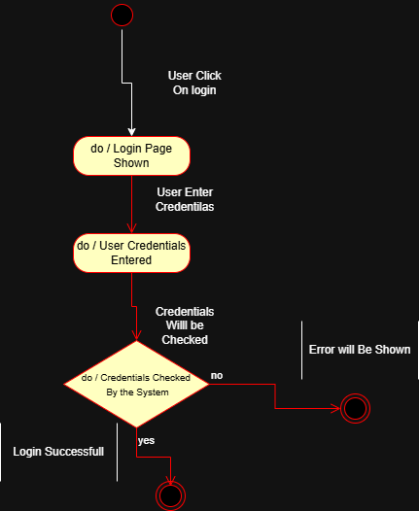

Logout

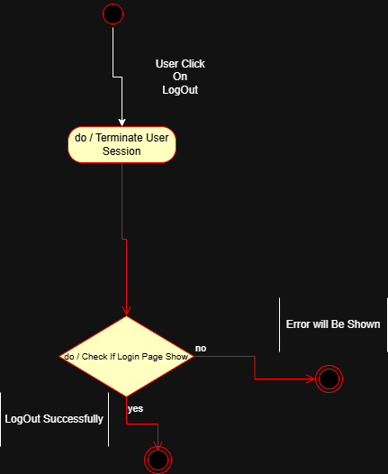

Add New Facility

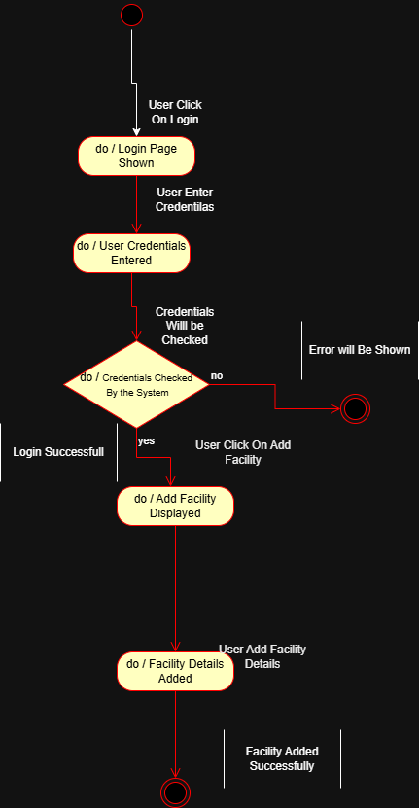

Add New Faculty

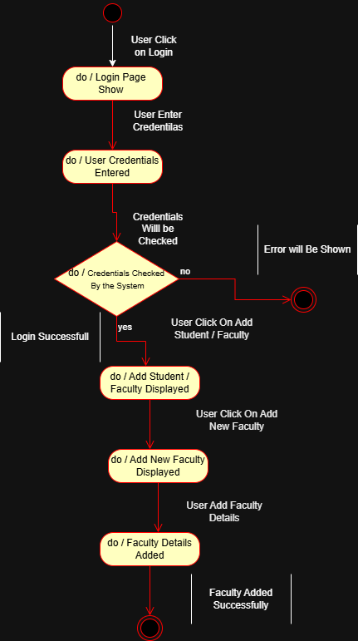

Add New Student

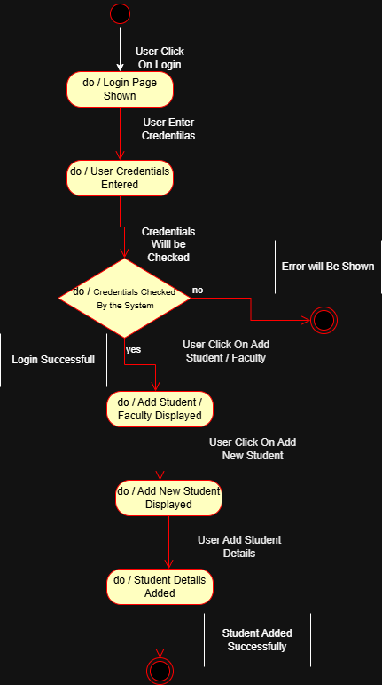

Approve Or Reject Booking

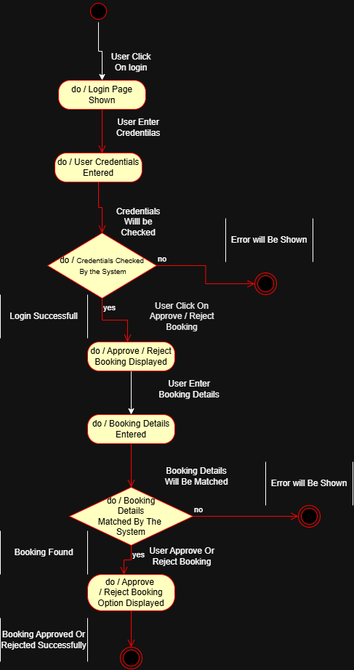

Generate Report

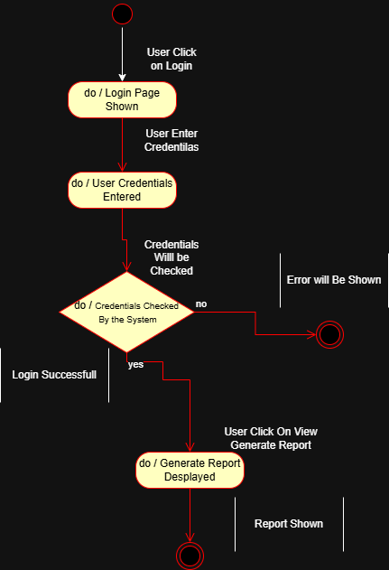

Remove Facility

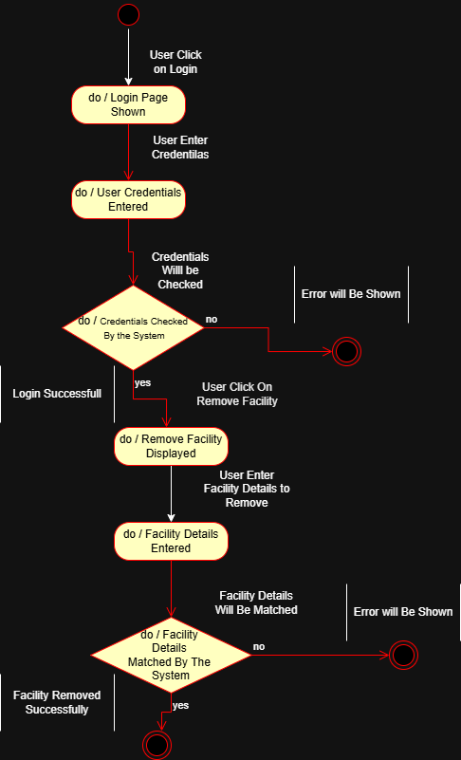

Remove Faculty

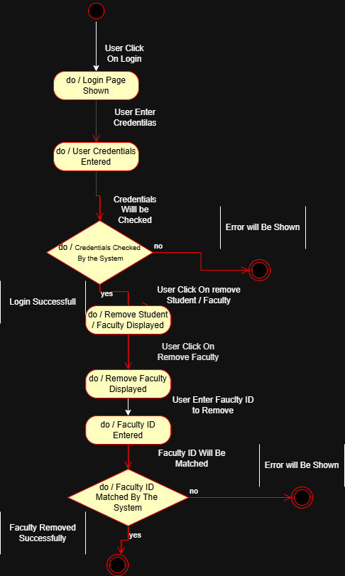

Remove Student

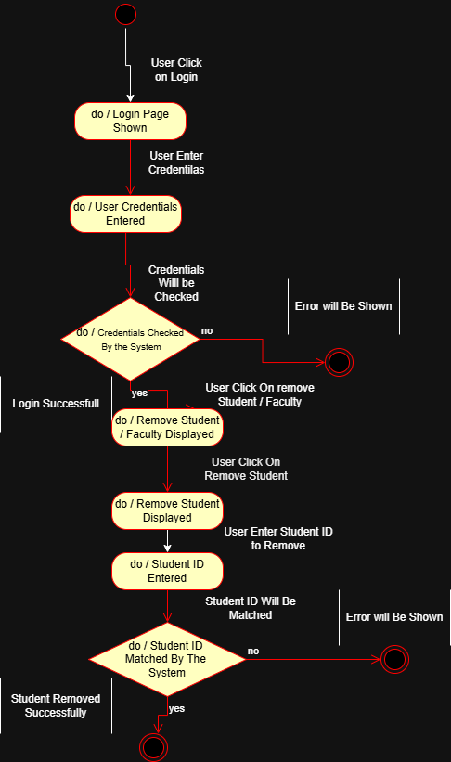

Update Facility

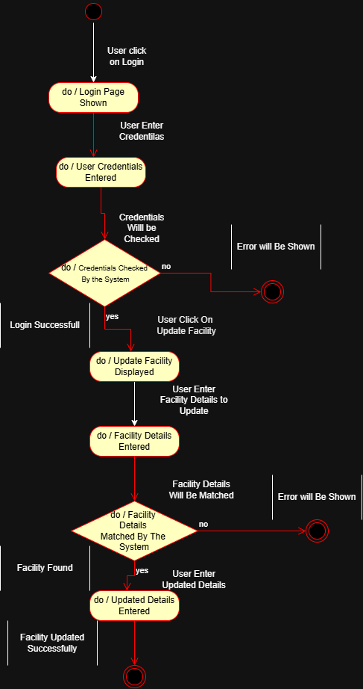

Update Faculty

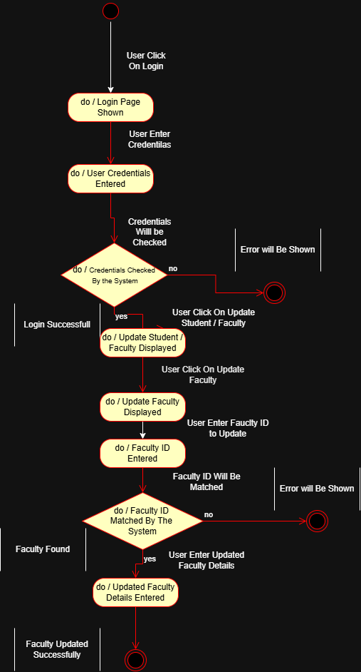

Update Student

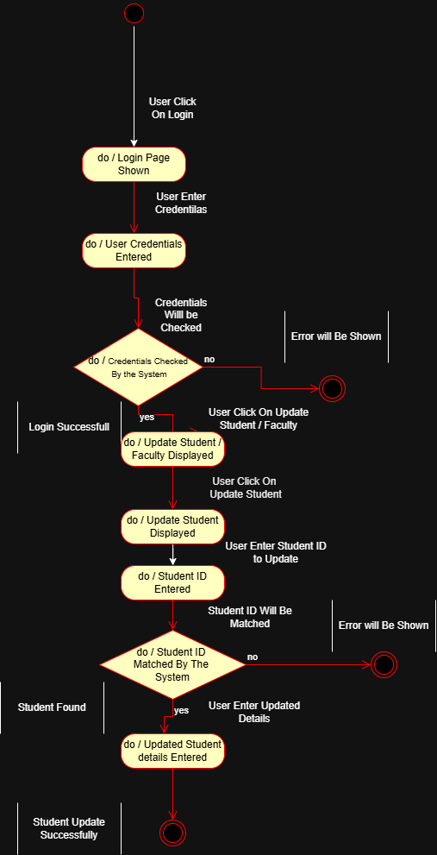

View Booking Requests

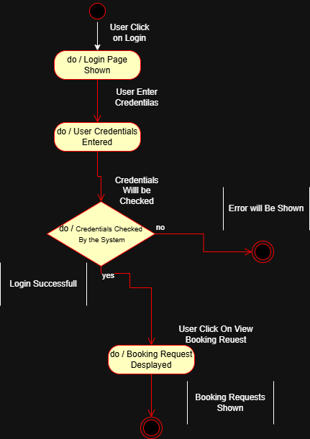

Faculty

Login

Logout

Request Booking

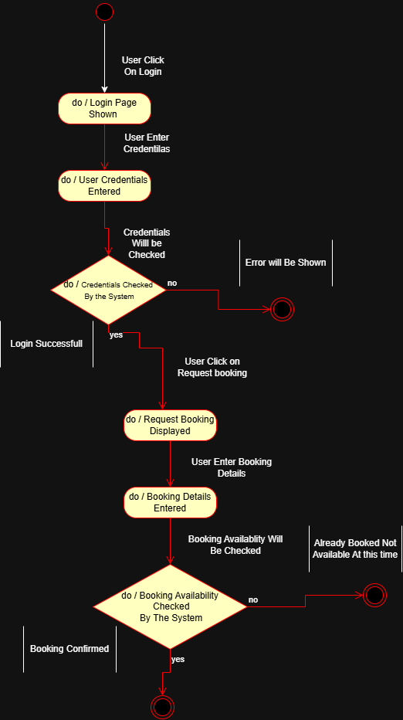

Cancel Booking

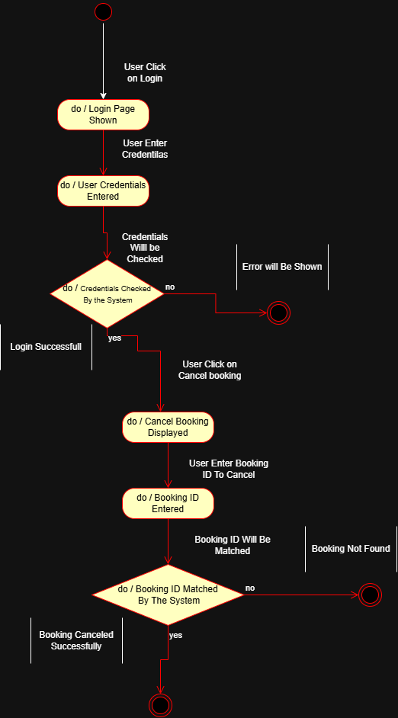

Update Own Details

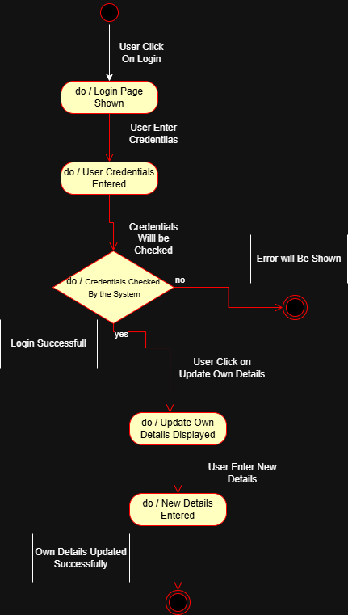

View Facilities

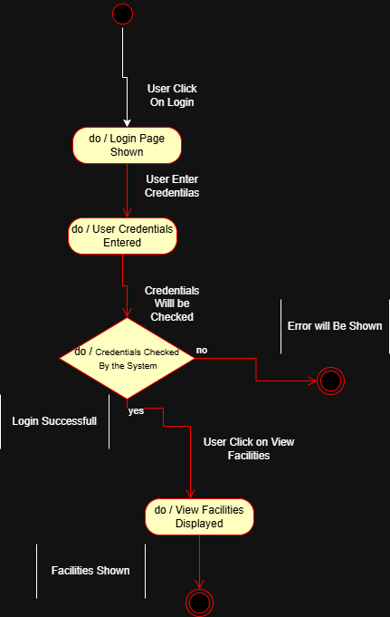

View Own Bookings

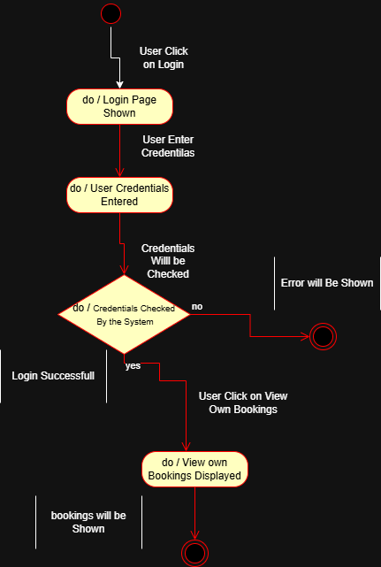

View Own Details
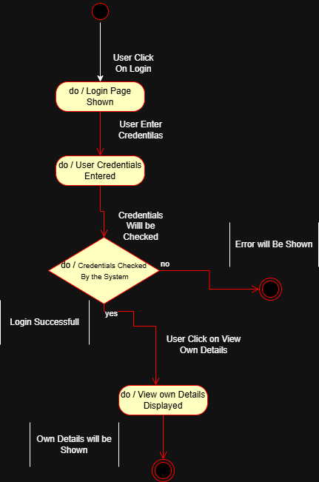

Student

Login

Logout

Request Booking

Cancel Booking

Update Own Details

View Facilities

View Own Bookings

View Own Details

